**OUR LITIGATION PRACTICE**

Our litigation team handles and helps clients navigate all types of large-scale and complex commercial litigations on a global basis. We have an in-depth industry knowledge across a diverse range of sectors and give our clients business ready advice that enables them to approach a dispute, and guide them to the most commercial resolution.

Litigations often present financial and reputational risks. Our team understands these risks, and offers our clients an integrated approach throughout all stages of the dispute life-cycle, and have the resources and the experience to see the client through every step of dispute resolution process and well-informed decisions.

Our lawyers have represented clients in their complex and sophisticated disputes before all types of trial, appellate, and regulatory tribunals and courts around the world. By partnering with us, you will have access to a team of focussed lawyers who will provide comprehensive and commercial solutions to your disputes.

Some highlights of our work are as below:

|  |  |  |
| --- | --- | --- |
| **Description** | **Jurisdiction(s)** | **Sectors** |
| Disputes against the former managing director and local partner handling a Singaporean companies’ coal and logistics division in Indonesia | Singapore, Indonesia | Resources and Infrastructure |
| Dispute under a charter-party settlement agreement between two Singaporean and Italian shipping companies | Singapore | Shipping |
| Dispute for non-payment under facility agreement between an Indian Bank and two Singaporean companies | Singapore | Banking & Finance |
| Dispute under the consortium agreement between Indian, Singaporean and UAE partners for conversion of a mobile drilling unit into an offshore production unit. | UAE | Oil and Gas, Shipbuilding |
| Dispute under a purchase agreement for cotton fibre between a buyer and a seller | Singapore | International Trade |
| Dispute between the limited partners and general partners under a fund management agreement | Mauritius | Funds, Real Estate |
| Post M&A dispute between an Indian and a Canadian Company | USA/Canada | Pharma |
| Dispute under a drilling services’ agreement between two oil and gas companies | India | Oil and Gas |
| Anti-doping dispute of 4 Powerlifting athletes that were tested positive at the 44th National Games, India | India | Sports |
| Constitutional challenge to the National Anti-doping Code, India | India | Sports |
| Post M&A dispute between an American private equity, an Indian Company and its FCCB holders | India | Private Equity, Technology |
| Dispute between an Indian company and a South-Korean bank under a performance bank guarantee | India | Oil and Gas, Banking |
| Disputes under a satellite supply and maintenance agreement between an Indian state-owned enterprise and an Israeli company | India | International Trade, Telecommunication |
| Dispute between an Israeli tech company and its Indian customer for non-payment of dues | India | Technologies |
| Dispute of a German company and its Chinese and Indian subsidiaries in their dispute for alleged deficiency in supply of solar pumps | India | International Trade |

**Recognition:**

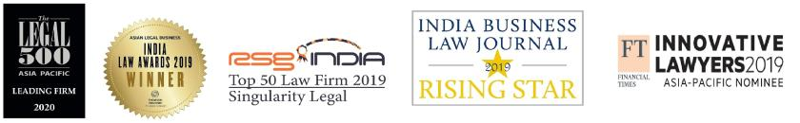

To find out more, please contact:

Prateek Bagaria

e: prateekbagaria@singularitylegal.com

m: +91 98200 25813

t: +91 22 4976 5861 Ext. 103